**Introduction to Notebooks**

**This demo uses Google Colab, but you are welcome to try Anaconda, PyCharm, Visual Studio, Other IDEs**

In this particular scenario, we are using Google Colab, which is fairly flexible in its configuration and does much of the heavy lifting for you.

* Python 3.6 support onwards
* Free GPU acceleration
* Pre-installed libraries: All major Python libraries like TensorFlow, Scikit-learn, Matplotlib among many others are pre-installed and ready to be imported.
* Built on top of Jupyter Notebook
* Collaboration feature (works with a team just like Google Docs)
* Google Colab allows developers to use and share Jupyter notebook among each other without having to download, install, or run anything other than a browser.
* Supports bash commands
* Google Colab notebooks are stored on the drive

If you prefer to read more before getting started, I recommend the [Welcome to Colaboratory](https://colab.research.google.com/#scrollTo=-Rh3-Vt9Nev9).

**Steps to use Colab**

1. Go to Colab webpage

[https://colab.research.google.com](https://colab.research.google.com/)

2. Upload your .ipynb file

First, go to File -> Upload notebook

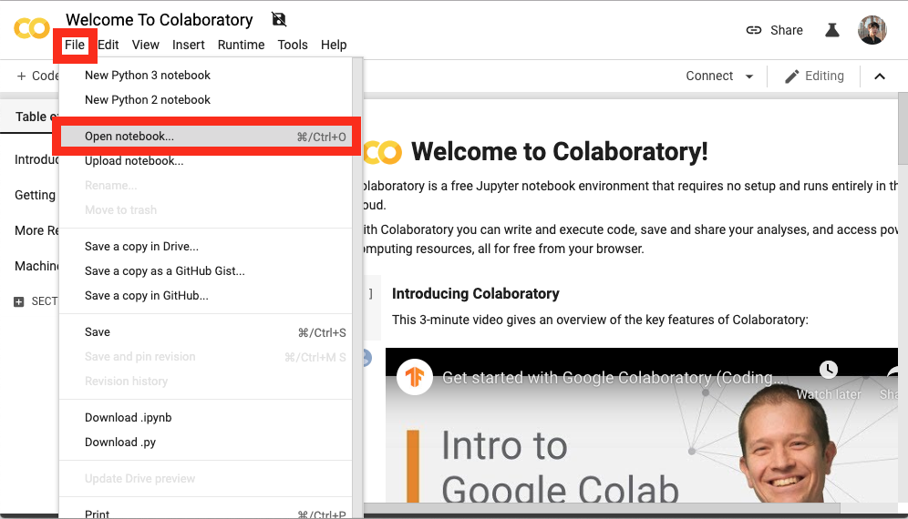

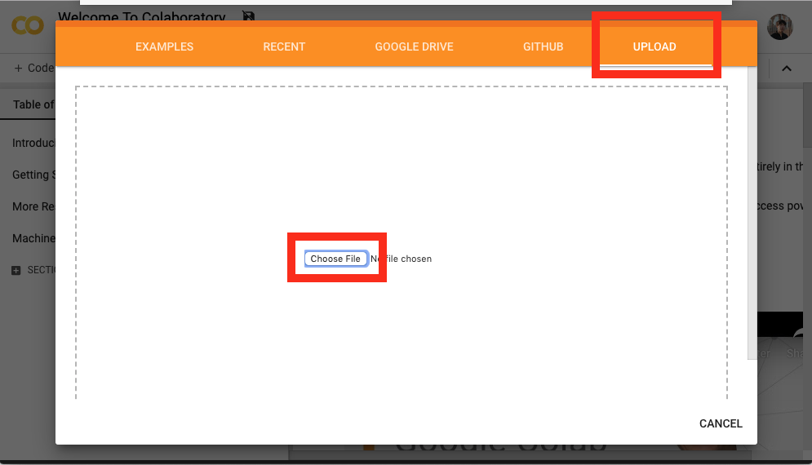

3. Connect to hosted runtime

Connect to hosted runtime by clicking the ‘Connect’ button.

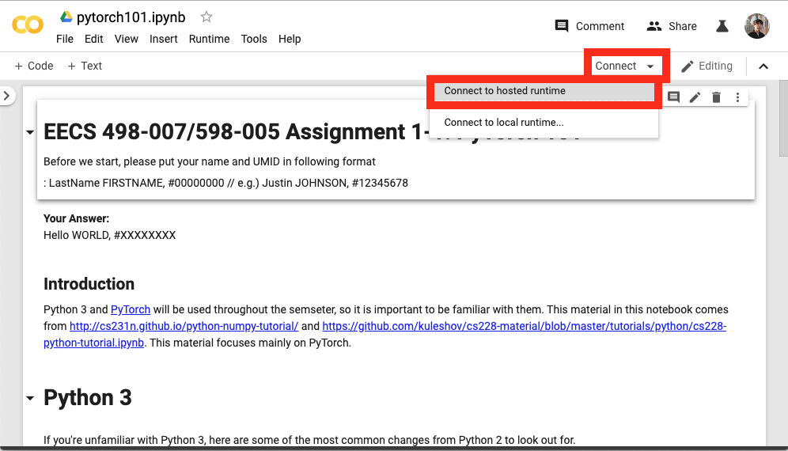

4. Execute the code one by one

Select each code box -> Click the ▶ button in each left top corner to run.

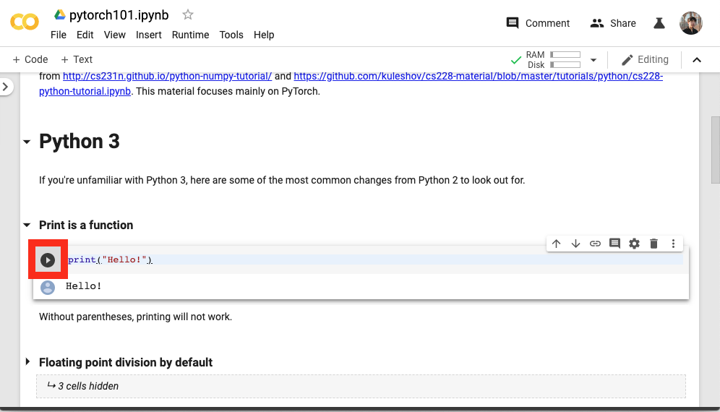

When you select any other code segments, then you should be able to see a number in [ ] area. If there is no number within [ ], then you need to re-run that segment.

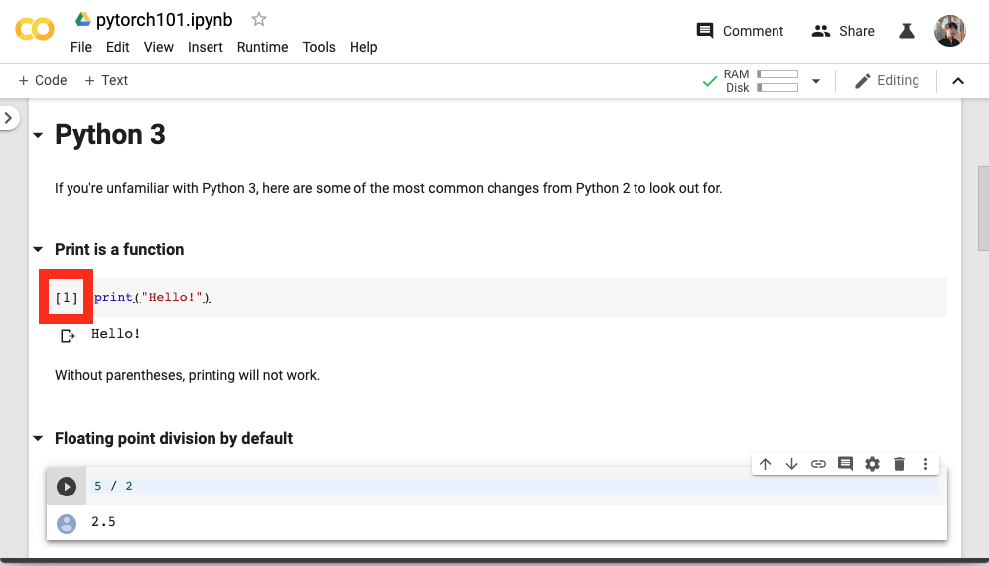

**File uploading**

**Option 1:**

You can upload files on Colab by using the file upload option that you can find on the top-left corner as shown below.

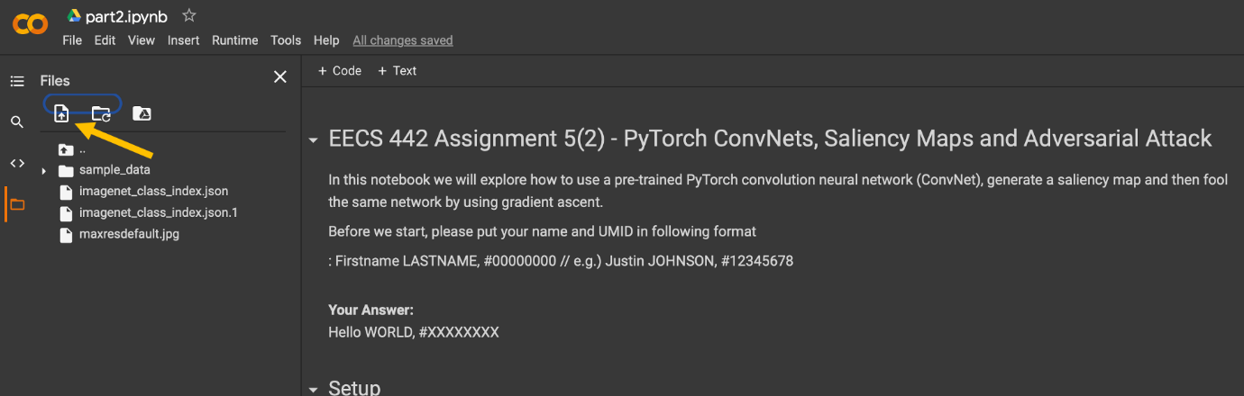

**Option 2: (Preferred)**

You can Mount your Google Drive to access all the Python (.pynb) files and other datasets for development and testing purpose using the following code:

# Mount Google Drive for reading videos and storing frames

from google.colab import drive

drive.mount('/content/gdrive/')

**Download the .ipynb**

Once you finish implementing all the codes, please download your .ipynb file. Please submit your .ipynb file with the outputs (Please DO NOT clear the outputs).

